|  |  |
| --- | --- |
| PROJECT DEVELOPMENT PHASE | |
| SPRINT DELIVERY – 3 | |
| TEAM ID | PNT2022TMID07016 |
| PROJECT NAME | Smart Farmer - IoT Enabled Smart Farming Monitoring Application |

# Configuration of Node-Red to send commands to IBM cloud

IBMIoT IN and OUT node I used to send data from Node-Red to IBM Watson device. So, after adding it to the flow we need to configure it with credentials of our Watson device.

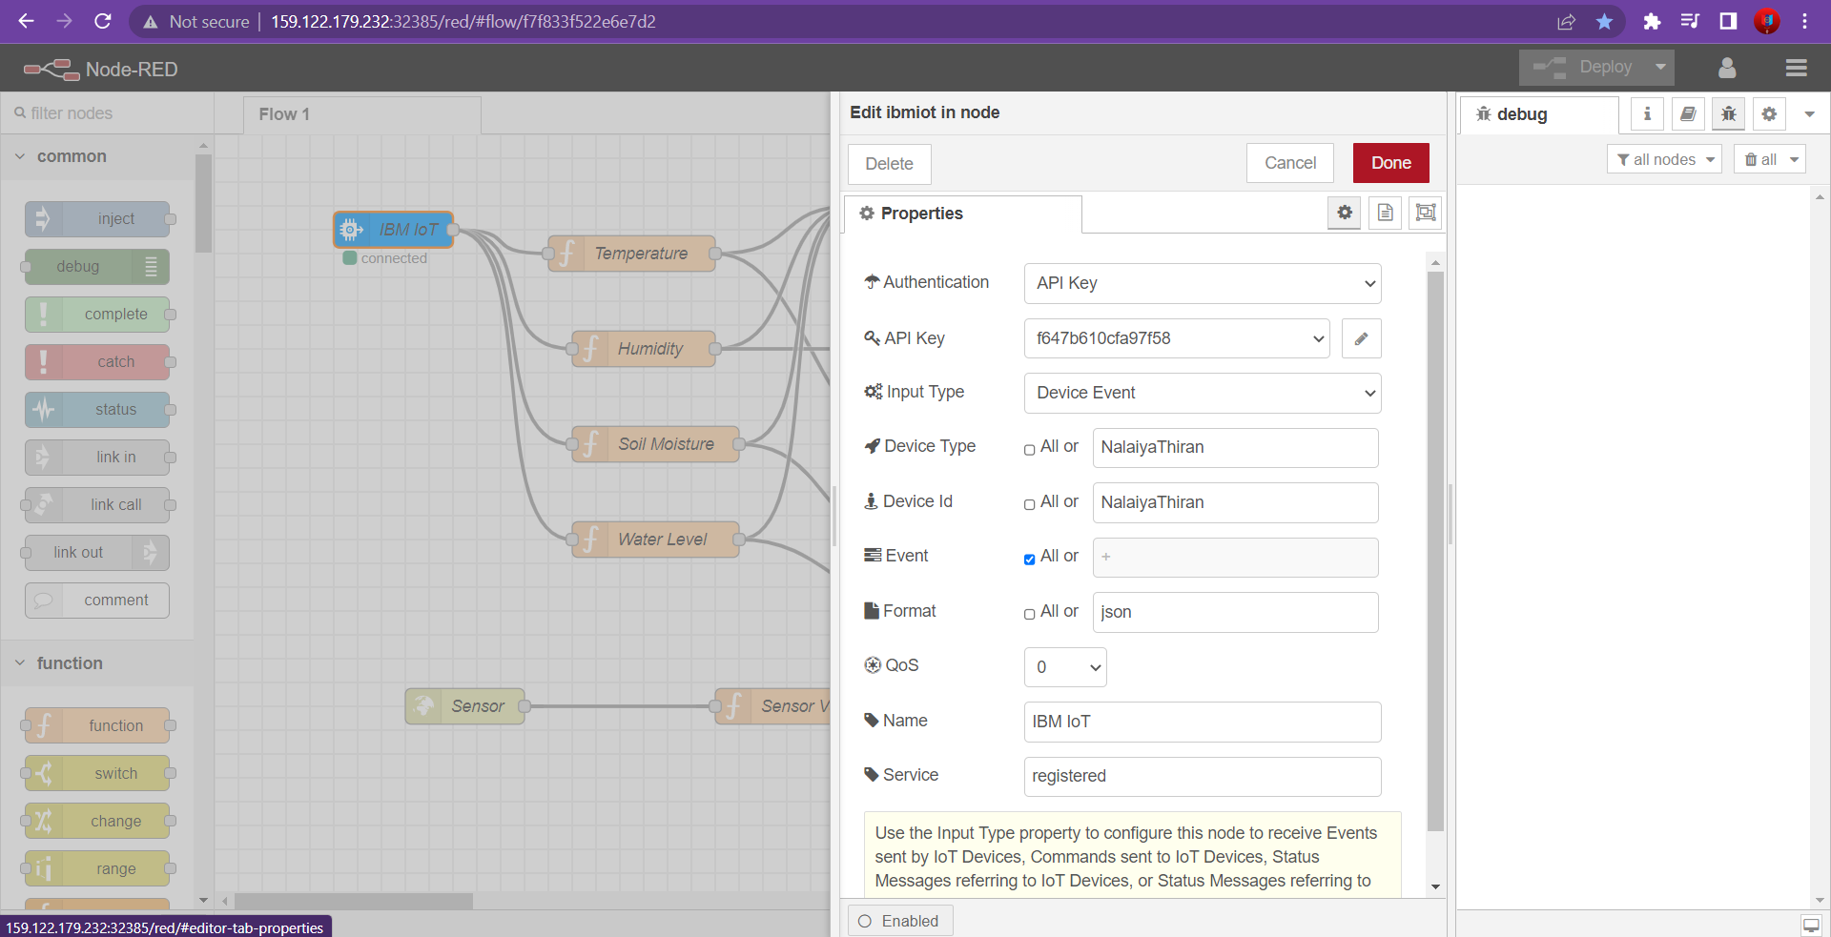

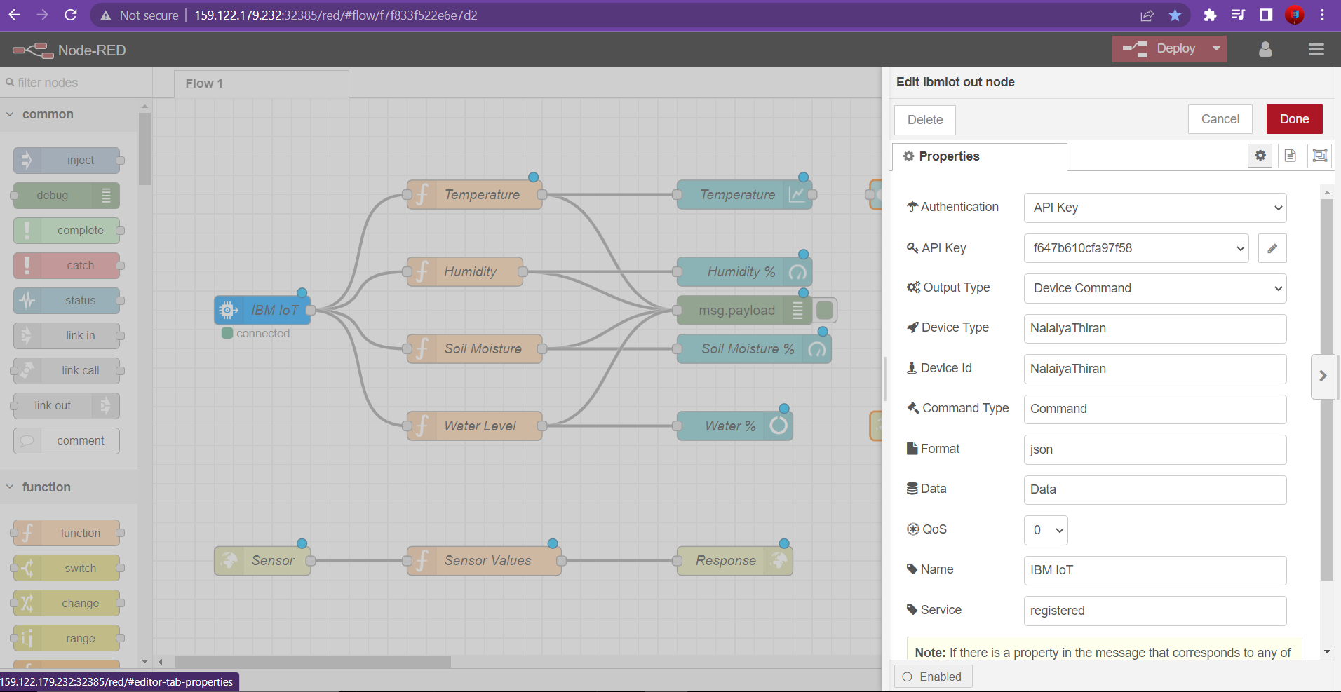

Switch button added in UI to control the motor

* Motor ON
* Motor OFF

We used a function node to analyses the data received and assign command to each state.

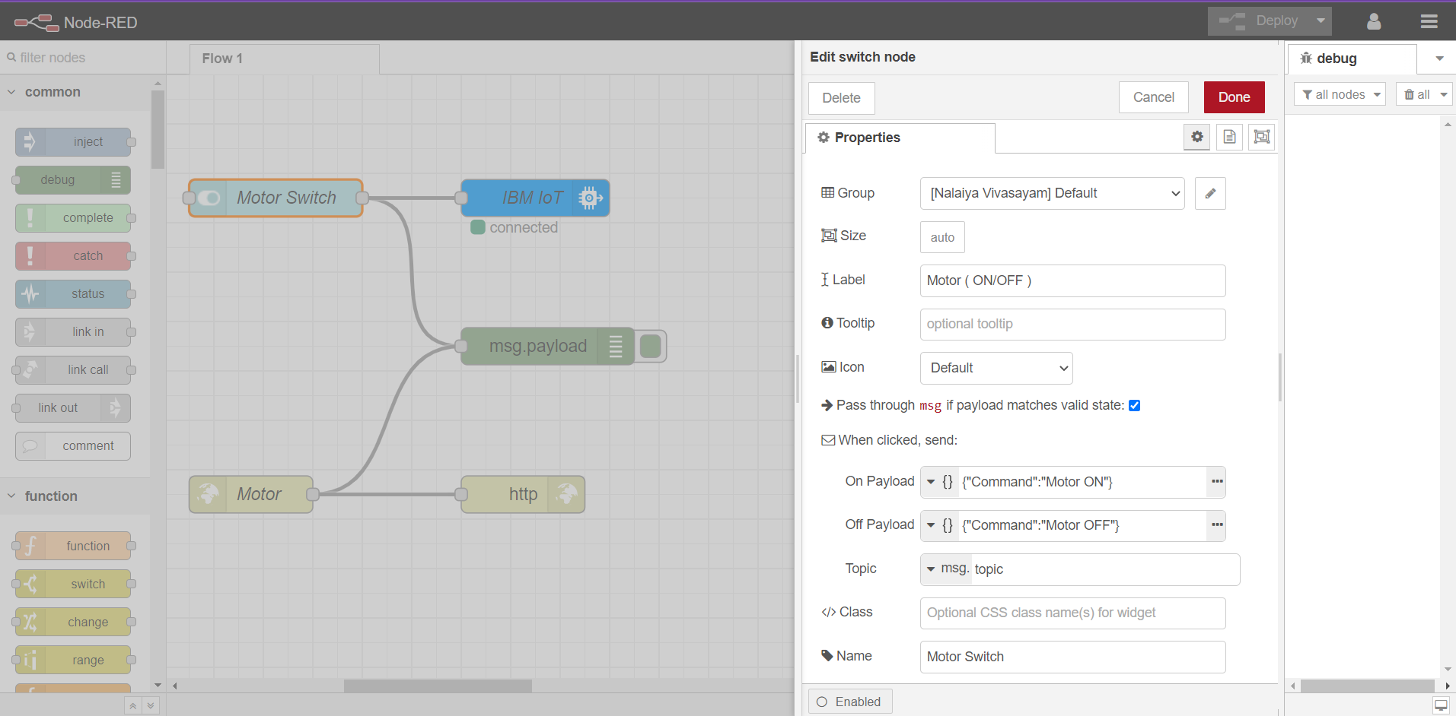

This is the program flow for sending commands to IBM cloud.

## Adjusting User Interface

In order to display the parsed JSON data a Node-Red dashboard is created

Here we are using Gauges, text and button nodes to display in the UI and helps to monitor the parameters and control the farm equipment.

Below images are the Gauge, charts and button node configurations.

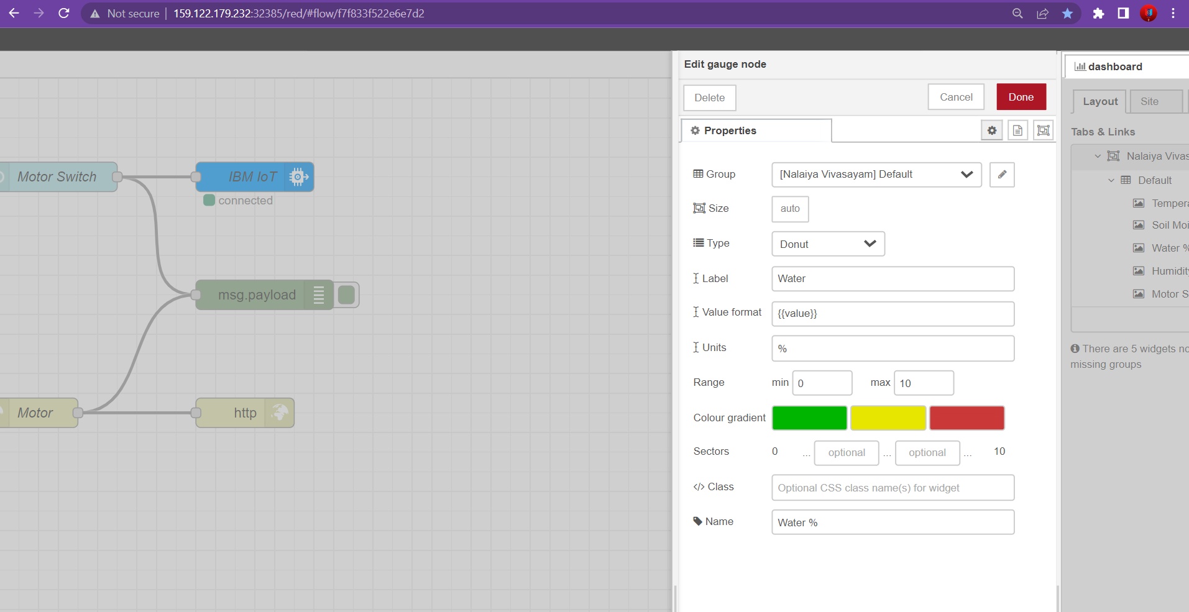

## COMPLETE PROGRAM FLOW

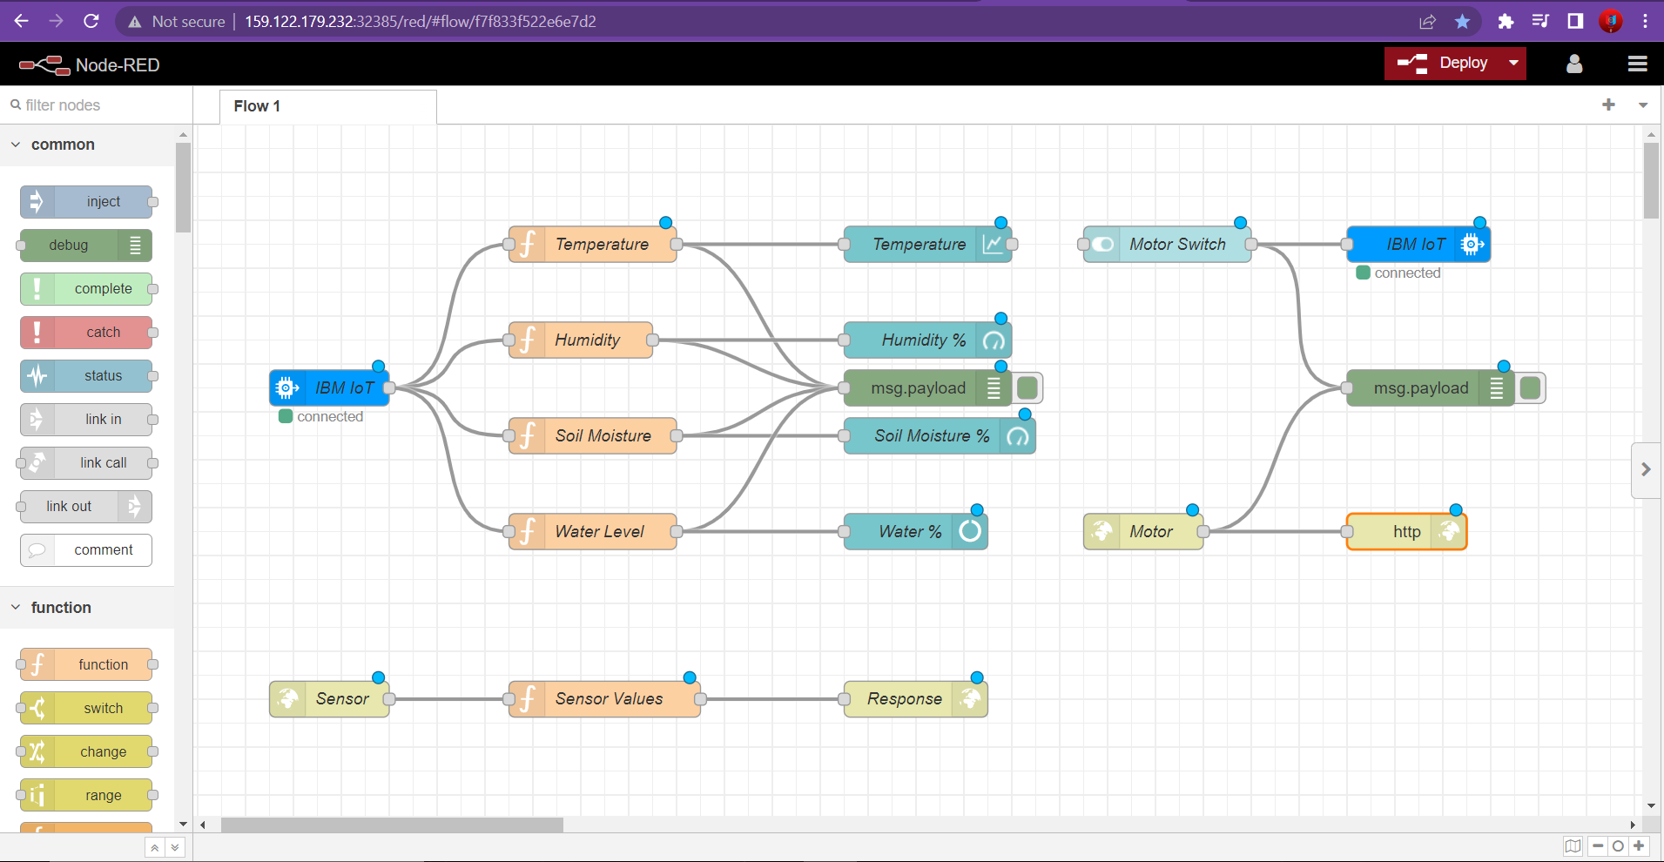

MOBILE APP DEVELOPMENT AND DESIGN:

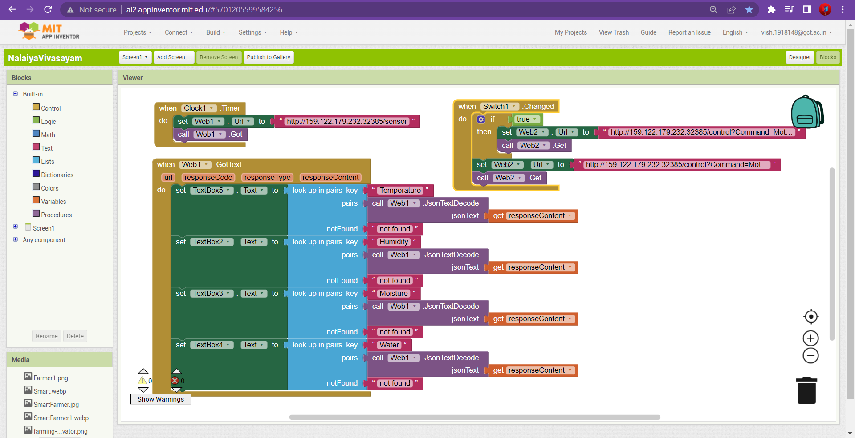

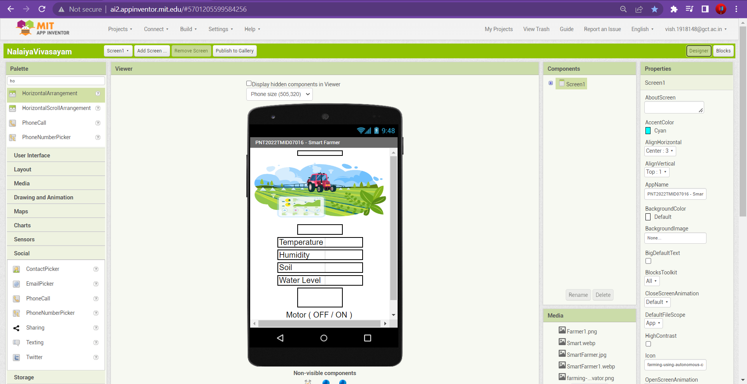

MOBILE APPLICATION:

